TG7100
Broadcast Control Panel

Features and Benefits
- Self-check is available
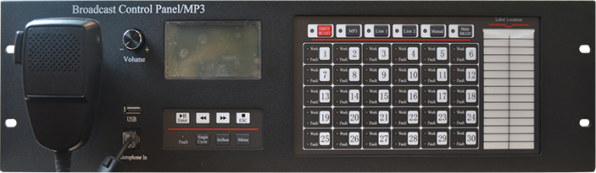
- Auto/Manual mode
- The monitor can be muted automatically to eliminate audio return while the microphone is used to broadcast
- As it receives the emergency signal, the power amplifier can automatically adjust audio to preset position not controlled by the volume potentiometer, eliminating the influence of human operation
- Automatically switching between the main power and the standby power
- Fault uploading
- Overheat protection
- Providing 24VDC off-set for local audio output line and line-checking module
- Communicate with TG7100 Broadcast Control Panel through RS485
Overview

The TG7300 power amplifier series is the new product that designed and manufactured by TANDA and provide 150, 300, 500 Watts of speakers power.

Technical Specification

Power Rating
Battery Required 3 VDC (2 x 1.5 AA) batteries
Current Consumption Standby 30µA, Alarm:100mA
Device
Communication NB-IoT
LED Indicator Single LED / 360-degree Visual/
Normal: Green LED Flash every 75 seconds
Alarm: Red LED Steady Light
Faulty: Yellow LED Flash every 45second
Material / Colour ABS / Red
Dimension 87mm x 85mm x 30mm
Weight 113g (with Battery)
Operating Temperature -10°C to +55°C
Humidity 0 to 95% Relative Humidity, Noncondensing

